# **Microwave oven**

**Introduction:**

*What microwave oven does*: A microwave oven is an electric oven that heats and cooks food by exposing it to electromagnetic radiation in the microwave frequency range. Microwave oven heats food quickly and efficiently because it channels heat directly to the molecules inside the food. In addition to their use in cooking food, microwave ovens are used for heating in many industrial processes.

There are different modes in a microwave oven like microwave mode, grill mode etc. In Microwave mode a magnetron inside generates high frequency waves in microwave frequency range which cooks food. In the grill mode, a simple grill heater is operated. We set the time for which the item has to be cooked/grilled. After the completion of time, it stops and leaves a message.

**Our prototype definition:** 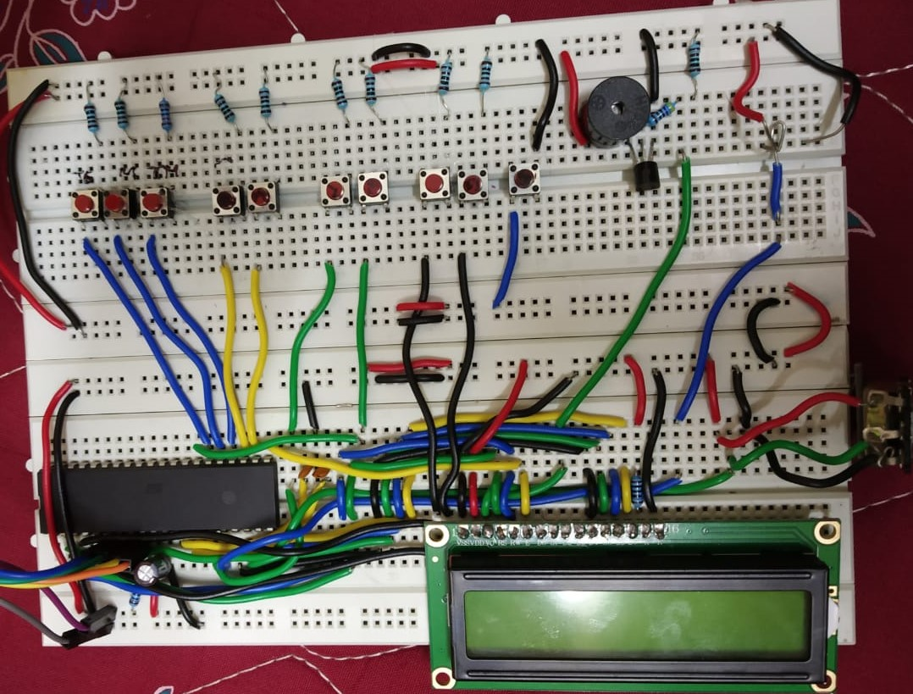

In our model, we provide user with 10 buttons, 9 LEDs, an LCD and a buzzer. Two buttons are provided to select one of the two Modes: microwave and grill. Three buttons are provided to increment the timer by 10s, 1min and 10min respectively.

A clear/stop button is provided to reset the timer while setting the time. This button is also used to pause the timer count down when the microwave oven is in the ON condition. Once the grill/microwave mode is pressed and the 600W/800W is set, the timer is set. Two buttons are provided to select one of the two power levels: 600W and 800W. After pressing start button, timer starts decreasing with the LCD of selected mode glowing. This button is also used to resume the timer in-case the user has paused the timer to open the oven and check the status of food. When the timer reaches 0, power gets off and a green LED glows for 12 seconds to indicate that the job is done, along with a buzzer long beep. A toggle switch is used to model an accidental door opening. A red led glows and the buzzer beeps when door is opened accidentally. Low frequency beep from the buzzer indicates that door is open while in configuration mode. A high frequency beep indicates “Danger” that door is opened while cooking.

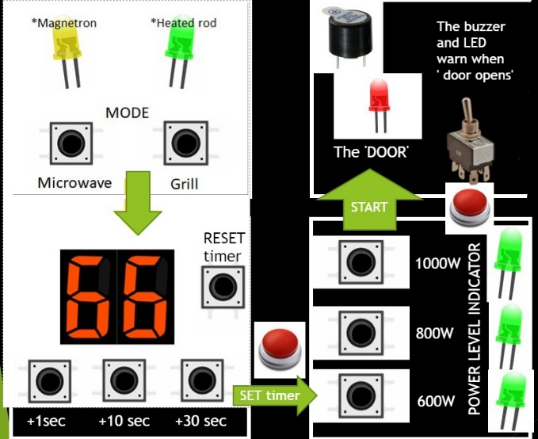

We have used Atmega32 as our microprocessor. Atmega32 consists of 40 pins, the pin diagram for the same will be given under circuit diagram. LCD has a total of 16 pins, the pin diagram is given under circuit diagram. We are demonstrating microwave oven using LCD display and LEDs. To attain high frequency stability, a crystal oscillator is being used in our model. Crystal oscillator produces stable output for prolonged time. A crystal oscillator is an electronic oscillator used for the mechanical resonance of a vibrating crystal. The vibrating crystal is made up of piezoelectric material. It creates an electric signal with a given frequency. A separate circuit was built to implement the interrupt caused by the accidental opening of the door while cooking. When the interrupt is being called, the timer value, mode, power level were pushed into the stack

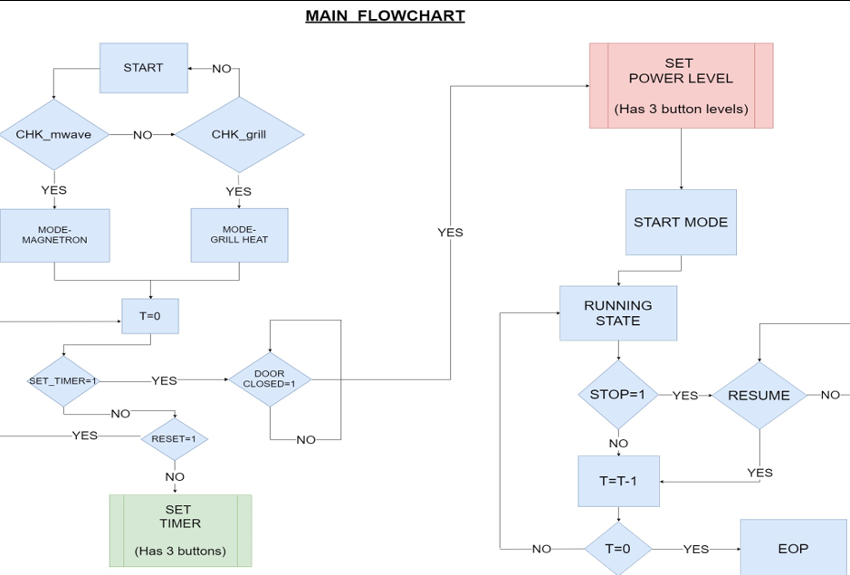

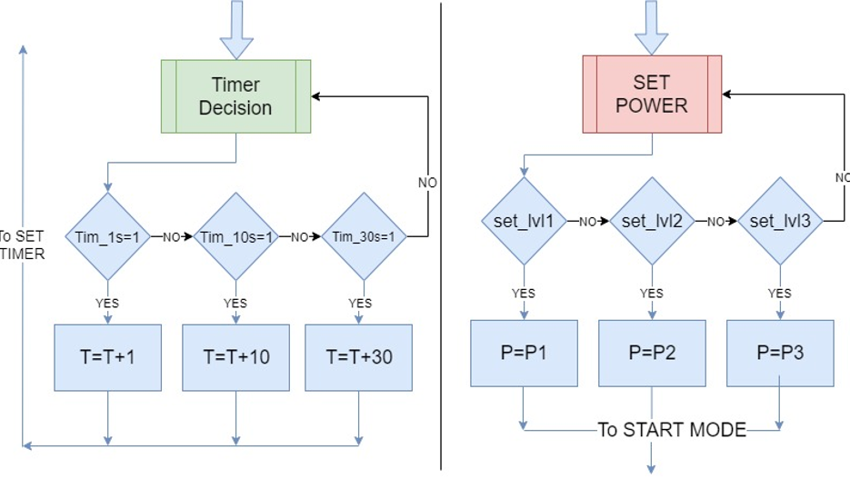

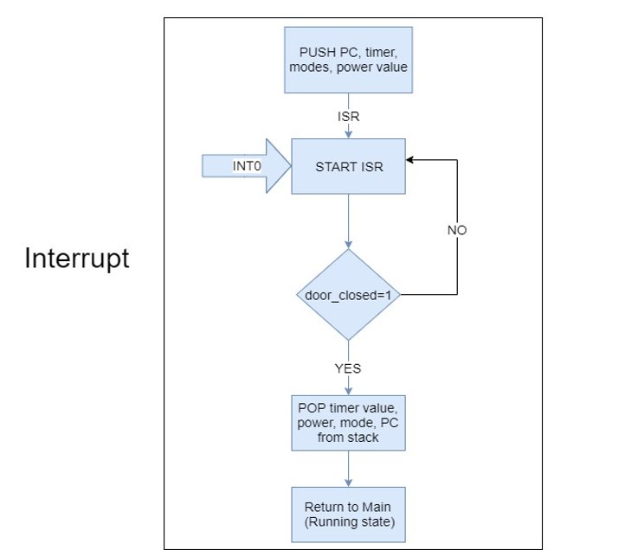

***Outputs and details:***

LCD: indicates if microwave mode is selected

LCD: indicates if grill mode is selected

LCD: indicates that the 600W power level is selected

LCD: indicates that the 800W power level is selected

LED red: glows whenever a button is pressed

Led 7: glows when running state is on

Led 8: glows when door is opened accidentally

Buzzer: beeps at high frequency when door is opened accidentally while running process is on.

: beeps at low frequency when the process is done.

: beeps once whenever a button is pressed.

LCD: shows Ready and asks for input initially

: shows the available modes and displays the selected mode

: shows available power levels and displays the power level selected

: shows the current timer value

: “ready” message is displayed once the process is done

: “Timer paused. Press Start” message is displayed when pause button is pressed.

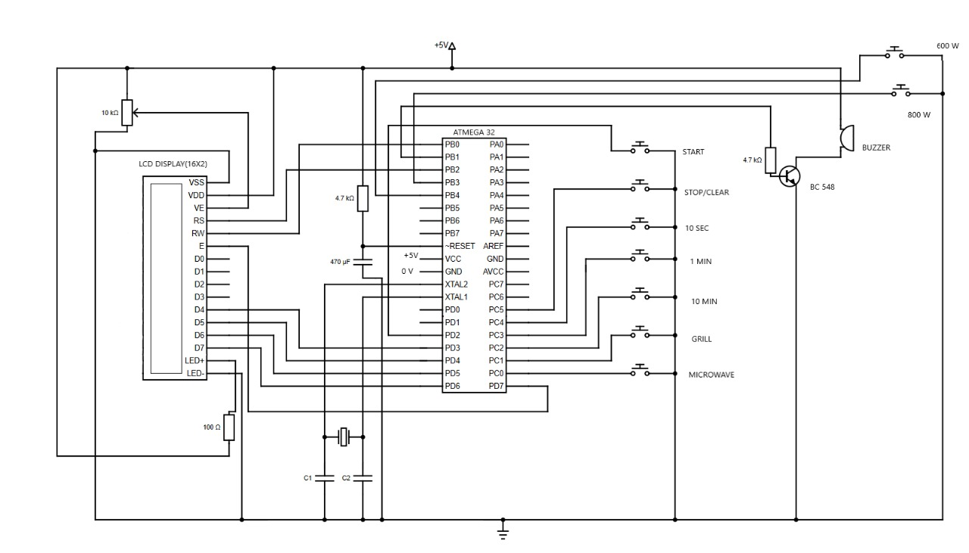**Circuit Diagram**

**Methods that we tried:**

We tried to implement Atmega8, but the number of pins were not sufficient. Hence, we implemented Atmega32 which has greater number of pins than that of Atmega8.

We tried to display the timer using two 7-segment displays, but the inherent circuitry became too complex on the breadboard with lots of criss-crossed wires. And also, we could show only a maximum of 99 seconds using two 7-segment displays without a demarcation of minutes and seconds. So we are using a 16*2 LCD display to display timer. Using LCD, we not only can display timer, but also mode and power level.

**Code**

The code has been attached in a separate file.

**Team members**

EE18B060 Arun

EE18B116 Hemanth

EE18B058 Navaneesha P

EE18B068 Rahul Vasanth

EE18B072 Siddharth D P

EE18B036 VVS Anirudh Sharma

EE18B042 Venkat Sai

EE18B152 Swapnil

EE18B138 Harshitha